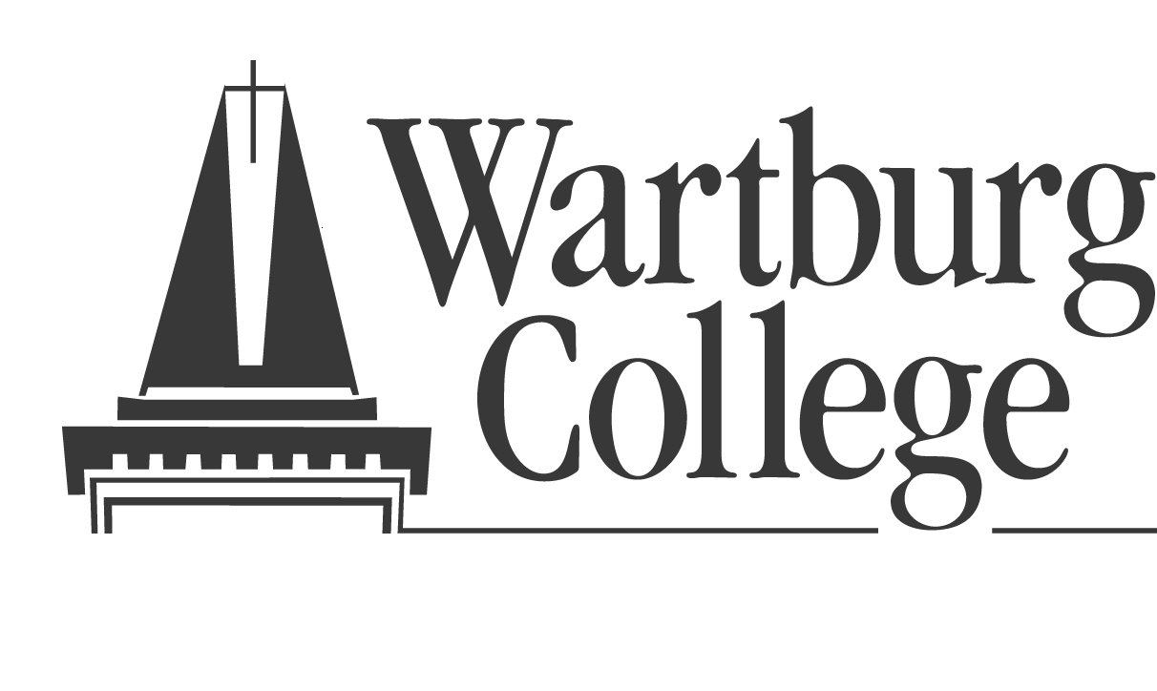 SOCIAL WORK DEPARTMENT
Agency Agreement to Provide Field Instruction

Agency:
Address:
Street Address City State Zip
Director or Designee:
Telephone:

Wartburg College Agrees to the Following:
- To coordinate the assignment of students to specific agencies by submitting tentative assignments to the appropriate agency administrator and to assign students who have satisfactorily completed the necessary academic and professional training program.
- To provide the agency with information about the placed students, including information about their academic preparation, previous experience, career goals, and placement needs.
- To provide qualified college instructors from the Social Work Department to consult regularly with the designated field instructor to discuss students’ progress in placement.
- To keep the agency apprised of developments in its social work field education program and will provide staff supervising students with orientation and training.
- The college and each student shall comply with all applicable state, federal, and local laws regarding the confidentiality of patient information and medical records. (HIPPA)

The Cooperating Agency Reserves the Right to and Agrees to the Following:
- To determine, with assistance from the college, which student(s) will be accepted for field placement.
- To assign a qualified person as a field instructor who will assume responsibility for student orientation, training, observation, and work assignments.
- To allow the student use of physical resources of the agency normally provided to agency personnel that is necessary and reasonable to enable the student to function in their field setting.
- To permit visitation and observation by Social Work faculty of Wartburg College.
- To provide supervision of the student by certified personnel at all times during the field experience.
- To place the student in control of groups only after s/he has demonstrated readiness and careful planning with the field instructor and college supervisor.
- To utilize the student in capacities approved by the Wartburg College Social Work Department. Any changes in the original assignment of the student should be discussed with the Social Work Department.
8. To offer the student the same protection as is afforded employees or volunteers of the agency through the agency’s liability coverage(s).
- The designated field instructor will prepare a written evaluation of students using forms provided by the college. The college will have final responsibility for determining student grades.

Authorized Agency Representative:
Date:
Field Education Coordinator:
Date:

