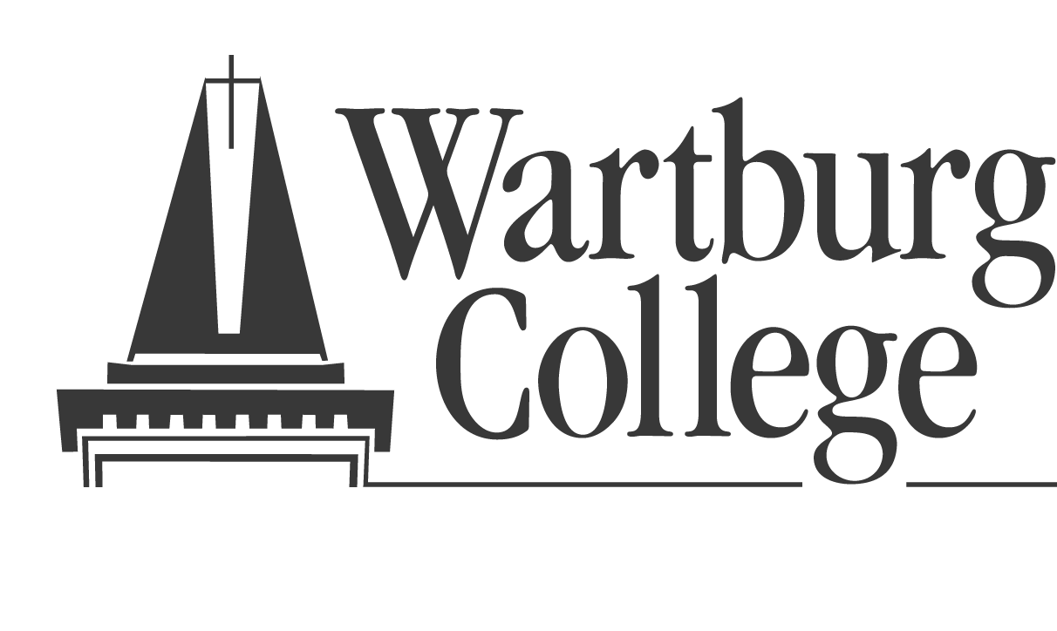

Department of Education

Mock Evaluation of Student Teachers on the Iowa Teaching Standards

House File 549 (Spring 2003) mandated that Iowa’s Teacher Preparation Programs provide a student teaching experience that includes opportunities for the student teacher to become knowledgeable about the Iowa teaching standards, including a mock evaluation performed by the cooperating teacher. The mock evaluation shall not be used as an assessment tool by the practitioner preparation program. This mock evaluation does not require that the evaluator be state evaluator approved or that the student teacher provide documentation to support competence.

I VERIFY that I have conducted the Mock Evaluation of

____________________________________________________(Student Teacher)

on _________________________________(Date)

Cooperating Teacher or Designee: __________________________________

School:_____________________________________________

Please return to the Wartburg College Education Department.

Students may not be licensed without this verification.

