Correcting Workforce Client Problems Related to Java Updates

Information

Goal:
- Due to the release of Java updates, and the associated Workforce updates required to work correctly with the new Java security model, there have been many reports of incorrect behavior on the Workforce Java clients. The behaviors can be different depending on Java version, browser, and environment but may include:
  - White screens or “dancing lines” where you expect to see data
  - Some features in Workforce not loading properly.
  - Workforce Navigator stuck on "Loading Libraries"
  - Java security warning or errors.
  - Slow response when opening Workforce
  - Some links such as Timecard, Schedule or People quick navigation links not working
Environment:

- Workforce Central (WFC) v6.1, v6.2, v6.3, v7.0

Answer:
Here is a list of steps to take that will help resolve most Java client issues.

1. To avoid Java update prompts, apply the latest version of Java client plugin. Any version of Java more than one release old will generate prompts to update Java.

https://java.com/en/download/

2. Verify that the Internet Explorer add-ons are enabled for the Java ActiveX controls and not filtered out.
Tools> Manage add-ons > Select any disabled Java ActiveX controls and click: Enable.
Tools Menu> ActiveX Filtering > Click to clear any checkbox

3. Clear Java temporary internet files (cache) from the Java Control Panel

Information

Goal:
- How do I clear the Java cache in JRE version 1.6.0 and higher?

Environment:
- Workforce Central (WFC) v7.0, v6.3, v6.2, v6.1, v6.0

Find the Java Control Panel
» Windows http://www.java.com/en/download/help/win_controlpanel.xml
» Mac OS X http://www.java.com/en/download/help/mac_controlpanel.xml

Answer:
- Open the Windows Control Panel.
- Double click on Java.
- On the General tab, in the section labeled Temporary Internet Files, click the Settings button.
- Click on the Delete Files button.
- At the prompt that says "Delete Files and Applications", all checkboxes should be selected and click OK.
- It may take a few minutes for the system to finish deleting the files.
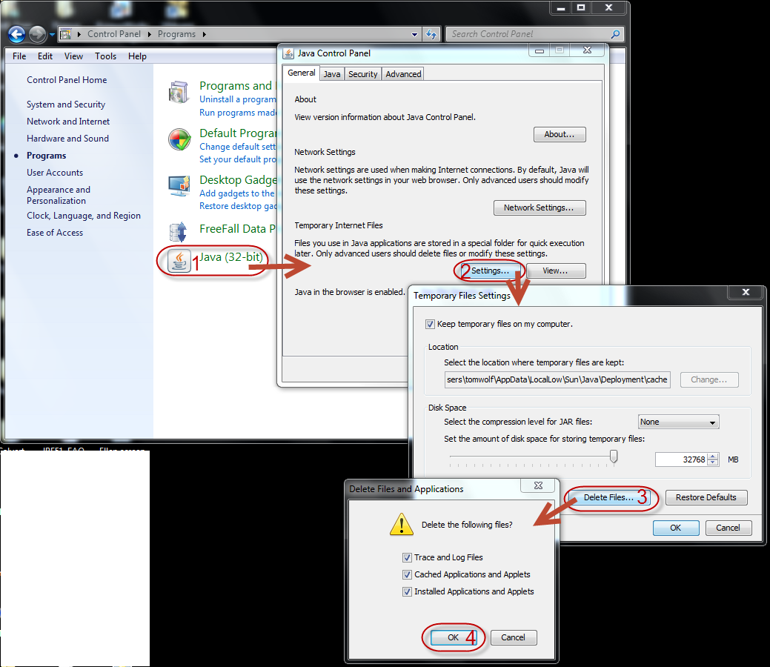

4. In the Java control panel advanced tab, set the "mixed code" setting to "Hide warning and run with protections". This slightly lowers Java security -- check your site security policies before implementing this change.
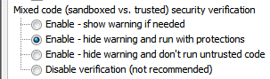

Information

Problem:
Upon logon to WFC the above dialog message pops up with the following question..
“Block potentially unsafe components from being run? (recommended)”
The choice is ..Yes or No.
Towards the bottom of the dialog screen you will see the message.
“The application contains both signed and unsigned code”.
Choosing “Yes” will most likely exit the program as it will block potentially unsafe components from running
Choosing “No” will allow the application or applet to continue execution and there will be no
further issues warnings or messages.
Sun-Oracle suggests that there is a way to modify the JRE settings with the mixed mode setting if this message is not desirable.
http://www.java.com/en/download/help/error_mixedcode.xml
If the above link is not working the following indicates the change that needs to be made in the java control panel.

Environment:
- Workforce Central v6.1, v6.2

Root Cause:
- This is a new security message that may occur with JRE's that are level 1.6.0_19 and higher.

Solution:
- To access the Java Control Panel go to Start menu > Control Panel > Java Control Panel > Advanced > Security
- Choosing the "Enable - hide warning and run with protections" option would be the same as choosing NO in the dialog box.
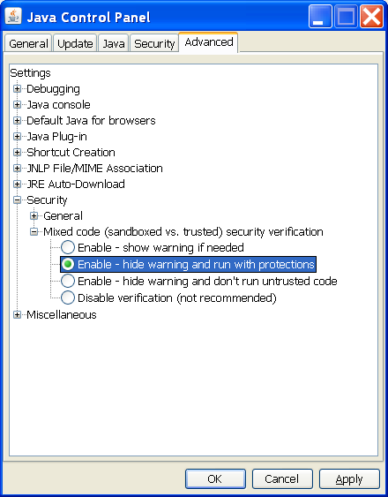

5. In the Java Control Panel, advanced tab, set the Java Certificate Revocation check to "CRL only". This slightly lowers Java security -- check your site security policies before implementing this change.

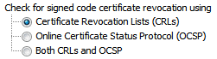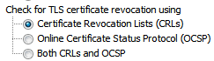
On Microsoft Windows, if both the 32-bit and 64-bit versions of Java are installed, this panel is not available. In this event, you have to launch the Java Control Panel directly from the 32-bit directory command line (C:\Program Files (x86)\Java\jre7\bin\javacpl.exe).
Option 1:
Go to the Advanced tab of the Java Control Panel and change the following settings to
• Perform Certificate revocation checks on -> Publisher’s certificate
• Check for Certificate revocation using -> Both CRLs and OCSP
Restart browser and verify if this improves the performance. In case the performance doesn’t improve attempt the following option:
Option 2:
Go to the Advanced tab of the Java Control Panel and change the following settings to
• Perform Certificate revocation checks on -> All certificates in chain of request

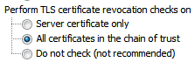
• Check for Certificate revocation using -> Certificate Revocation Lists (CRLs):

Default Setting:
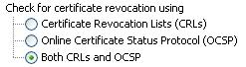
Modify to the top radio button to disable OCSP checking:
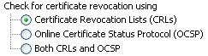
Important Notes: This setting change will have a client-side impact across the JRE and other applets that may be used.
------------------------------------------
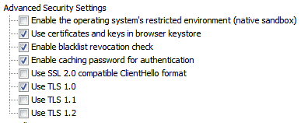

6. Clear browser temporary files (cache). Instructions will vary by browser type.
Internet Explorer 8 and above
1. From the Safety menu in the upper right, click Delete Browsing History.
2. Deselect Preserve Favorites website data, and select Temporary Internet files, Cookies, and History.
3. Click Delete.
Firefox 3.5 and above for Windows
1. From the Tools menu, select Clear Recent History.
2. From the Time range to clear: drop-down menu, select the desired range; to clear your entire cache, select Everything.
3. Click the down arrow next to "Details" to choose what history elements to clear (e.g., check Cookies to clear cookies). Click Clear Now.
Safari
1. From the Safari menu, select Reset Safari.
2. From the menu, select the items you want to reset, and then click Reset. As of Safari 5.1, Remove all website data covers both cookies and cache.

Firefox 3.5 and above for Mac OS X
1. From the Tools menu, select Clear Recent History.
2. From the Time range to clear: drop-down menu, select the desired range; to clear your entire cache, select Everything.
3. Click the down arrow next to "Details" to choose which elements to clear. Click Clear Now.

7. Disable any pop-up blockers in the browser or from any 3rd party tools. They might suppress something that needs to be acknowledged. Instructions will vary by browser or tool. (http://www.wikihow.com/Disable-Popup-Blockers)
Microsoft Internet Explorer:
- Open Internet Explorer and click on the Tools button.
- Click on "Internet options".
- Go to the Privacy tab.
- Click Turn Off Pop-up Blocker to disable the functionality.
- If you want to choose which websites to allow and still keep the blocker functionality, click "Pop-up Blocker Settings" instead.

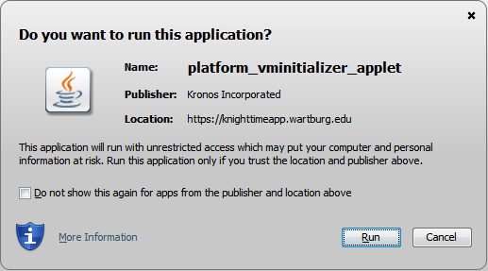
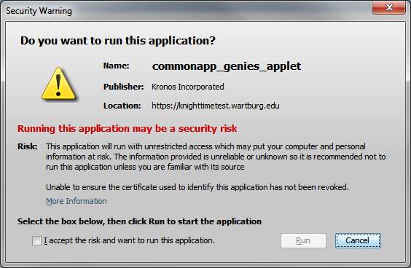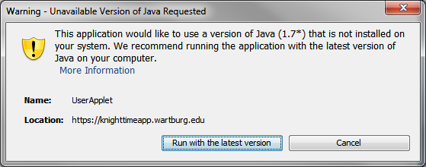
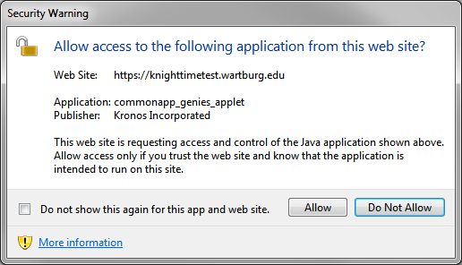

8. In internet Explorer > Tools > Internet Options > General tab > Browsing History > Settings > Temporary Internet Files tab > set Check for newer versions of stored pages to: Every time I visit the webpage.

9. Reset the Java security prompts. Java usually recommends this when you apply a Java update. This means users will get prompted again for any prompts they had previously set to remember.
Open Java Control Panel
Go to the Security Tab
Click the button to "Restore Security Prompts"
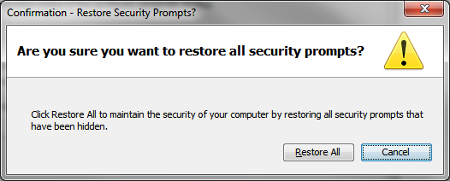
Click Restore All

